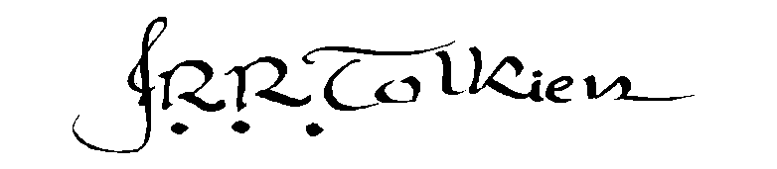SOTHEBY’S
VALUABLE PRINTED BOOKS AND MANUSCRIPTS
– J.R.R. Tolkien Lots –

London: 13 December 2001
Sale Code: L01321. Sale name: “Camel”

All lots are offered subject to Sotheby’s standard Conditions of Business

546 [Tolkien, J.R.R.]--Onions, C.T. The Shorter Oxford English Dictionary. Oxford: Clarendon Press, 1956

4to, 2 volumes, j.r.r. tolkien's personal copies with occasional annotations, signed by Tolkien on front free end-papers, original cloth, creasing to occasional leaves, bindings slightly worn and soiled, spotting and soiling to edges

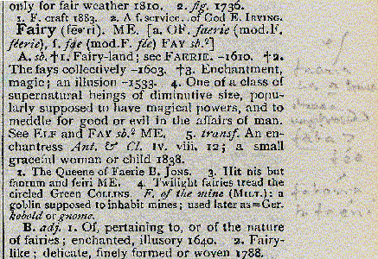
In November 1918 Tolkien joined the staff of the New English Dictionary as an assistant lexicographer working on the later stages of the work. The project had been started in 1878. However, by 1918, letters U to Z were still incomplete.

Tolkien claimed that the period until 1920 during which he worked on the Dictionary was one in which he ''learned more... than in any other equal period of my life''.

These copies of the abridged form of the dictionary carry numerous annotations in Tolkien's hand. Tolkien's background in philology and Old English are obvious in his etymological notes. He notes the plural form of 'elf' as 'elves' (I, 593), provides additional information on 'fairy' (I, 669) and annotates 'rune' (II, 1770). Adding an entry of his own, Tolkien defines 'Bag-end' as 'a cul-de-sac or a house that stands at the closed end of one'.

£1,000-1,500
EURO 1,600-2,450
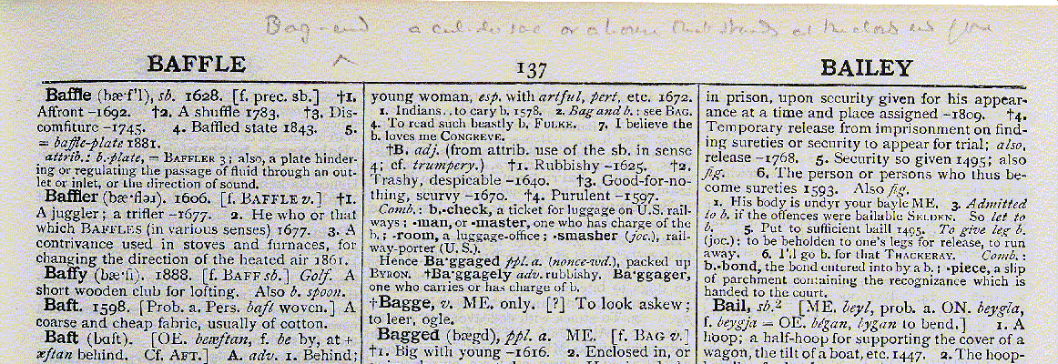

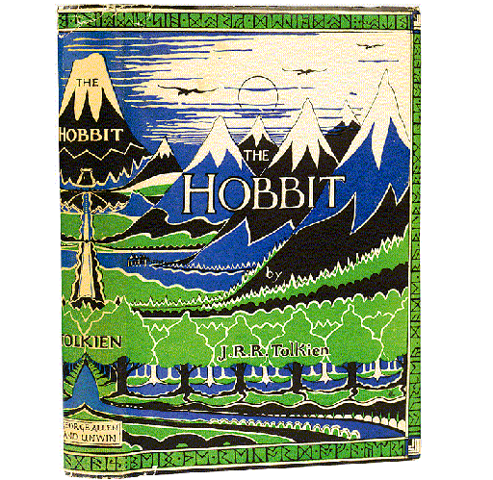
(lot 547)

The Property of Mr. Stamos D. Fafalios

547 Tolkien, J.R.R. The Hobbit. George Allen and Unwin, 1937

8vo, first edition, first issue ('Dodgeson' corrected in ink on inside lower flap of dust-jacket), 10 illustrations and pictorial endpapers in red and black by the author, 2 pages of publisher's advertisements, original pictorial green cloth, original pictorial dust-jacket by the author, in collector's slipcase, occasional minimal light browning to dust-jacket, slight loss to head and foot of spine, head of spine slightly creased, three repairs to reverse of dust-jacket

a fine copy of the volume preserved in an exceptionally good and bright dust-jacket

References: Hammond and Anderson A3a

£12,000-16,000
EURO 19,400-25,900

548 Tolkien, J.R.R. The Hobbit. Boston and New York: Houghton Mifflin Co., 1938

8vo, first american edition, first issue (bowing hobbit on title-page), coloured frontspiece, 3 coloured plates, 10 illustrations and pictorial endpapers in red by the author, original tan cloth (without ribbing) printed in blue and red, some spotting and browning, owner's name erased from front free end-paper, ownership signature and other slight ink markings to front end-papers and initial blank, binding slightly soiled and frayed at extremities, some slight splitting towards gutter

References: Hammond and Anderson A3b impression 1

£1,000-1,500
EURO 1,600-2,450

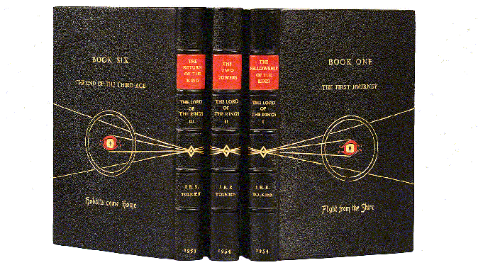

549 Tolkien, J.R.R. The Lord of the Rings. George Allen & Unwin Ltd., 1954-55

8vo, first editions (volume three in first state of first impression), volume one signed by the author with inscription in the author's feanorian script, author's signature laid-down to other volumes, autograph note by tolkien laid-down to volume one refering to the titles of the six books, 3 volumes, folding map at the end of each volume, bound in black morocco gilt by Bayntun with design of ring in gold and the eye of Sauron composed of red morocco onlays on both covers of each volume, the author's original titles and the owner's sub-titles in gilt, spine gilt in compartments, gilt edges (3)

these three volumes are bound (with tolkien's personal approval) bearing the author's preferred titles for the six books.

The publication history of The Lord of the Rings suggests that Tolkien was not content with the three volume edition as first published by Allen and Unwin. Humphrey Carpenter states in his biography of Tolkien that

...Tolkien was never entirely happy about the division, and he insisted on retaining The Lord of the Rings as the overall title. But after a good deal of discussion he and Rayner [Unwin] eventually agreed upon The Fellowship of the Ring, The Two Towers, and The Return of the King for the volume titles, though Tolkien really preferred 'The War of the Ring' for the third volume, as it gave away less of the story.

In a letter to Unwin dated 24 March 1953, published in The Letters of J.R.R. Tolkien, the author suggests titles for three volumes and, again, in a letter dated 8 August 1953. In 1956 Peter Alford wrote to Tolkien asking permission to bind this set with his own sub-titles. Tolkien approved but also detailed his preferred titles (see lot 550):

...I think your own choices may stand. The only real divisions are, of course, the ''books''. It may interest you to know what the titles were to have been, before the decision to publish in three parts.
I The First Journey (the Ring sets out.)
II The Journey of the Nine Companions (the Ring goes South)
III The Treason of Isengard
IV The Journey of the Ringbearer (the Ring goes east)
V The War of the Ring
VI The End of the Third Age
The alternative or sub-titles in brackets would have been abandoned, I think.

The set was eventually bound with each cover corresponding to one of the six books. Tolkien's titles are lettered in capitals above a motif and Peter Alford's titles are lettered in capitals and lower case letters below the motif. A note by Tolkien is laid-down in volume one stating:

The titles of the six Books, the only proper division of ''The Lord of the Rings'', were those originally devised before its publication in three parts. Peter Alford has my approval of his own choice of sub-titles on his bindings. J.R.R. Tolkien.

The owner has added a note explaining Tolkien's greeting in Fëanorian script. A portrait of Tolkien is laid-down in the first volume and two contemporary reviews of The Return of the King are laid-down in the third volume.

Provenance: Sotheby's (Hodgson's Rooms) sale, 18-19 December 1980, included in lot 650

References: see Hammond and Anderson A5ai, A5aii, A5aiii

£15,000-20,000
EURO 24,300-32,300

550 Tolkien, J.R.R. Fine group of four autograph letters signed to Peter Alford mostly discussing a dramatization of ''the lord of the rings'', the naming of the books and providing an analysis of an elvish phrase

one apologising for lateness of reply (''...I have no secretary and am struggling with rather a large (and interesting) correspondence, on top of the already fairly full-time job I have...'') and expressing at length his views about a radio adaptation of The Lord of the Rings

...most (but not quite all), of those who have expressed opinions to me, have agreed in horror or distaste, if they have read and liked the book. Those who have come direct to the broadcast have got more out of it, and have at any rate been led to the book in some cases. I am 'anti-dramatic' in tastes, anyway; and think 'drama' is a wholly different art from literature, though it may use words; as different as (say) sculpture from painting...

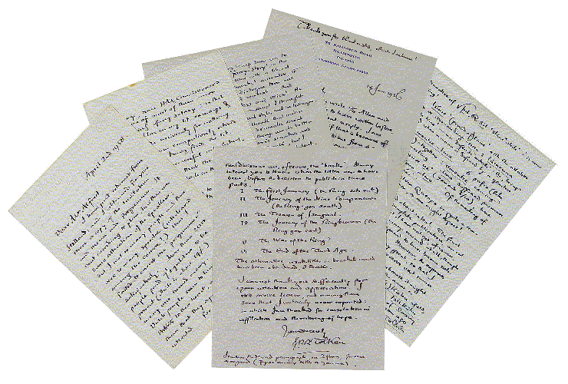

Discussing the ''damage and confusion'' caused to literary criticism by ''treating 'drama' as 'literature'...'' Tolkien notes this is ''...owing to the dominant position of Shakespeare''. He then discusses dramatizations of narratives and, specifically, the B.B.C. adaptation of The Lord of the Rings (''I am personally arrogantly convinced that I could myself devise a better libretto, but I have not the time''). He regrets his ''remark that I thought of my Dwarves like Jews, in character and position'' as this ''produced an accent like that of Edward VII'' and notes useful publicity from the broadcasts. Tolkien concludes by stating his hope that he would like, someday, to receive ''some small emolument from my labours, though I should be (and am) surprised and grateful for getting between covers at all in these days...''

In the second letter Tolkien notes his feeling of being ''filleted'' after suffering from 'flu and provides details of his original titles for The Lord of the Rings (see lot 549)

In the third letter he suggests an alternative title for Book Four and provides a lengthy discussion of an Elvish phrase from The Fellowship of the Ring. He disusses royalties, tax and production costs of the books:

...I am glad about sales! The final accounts, after complete publication, are not yet made up; but I have not yet, of course, received any pecuniary reward at all, though I am popularly supposed to have become rich. I.T. will see to that! However, the expenses of publication were very great, so that I shall not in any case receive vast sums...

Finally Tolkien writes enclosing a printed leaflet detailing a ''Hobbit Dinner'' in Holland (''...the Dutch people seem to have taken Hobbits to their heart...''), suggesting some correlation with Holland as ''the very citadel of smoking'' and discussing the menu. He mentions ''very considerable'' royalties, but laments ''our present income-tax tyranny'' and concludes by stating that any news that his ''success if not a mere 'flash in the pan' is pleasant''.

11 pages, 8vo, 3 autograph envelopes, 76 Sandford Road, Oxford, 14 January 1956 to 2 April 1958

This lot includes the 1958 ''Hobbit-Maaltijd'' programme inscribed and with a few pencil annotations by Tolkien. This Hobbit Dinner is noted within Humphrey Carpenter's biography. There are also six newspaper clippings, and a five page autograph review of the first two volumes of The Lord of the Rings signed and dated ''C. Peter Alford 1954.'' It commences ''Not many have yet, I guess, found the immensely rewarding pleasure of losing themselves in Professor Tolkien's magnificent adventure The Lord of the Rings...''

Provenance: Sotheby's (Hodgson's Rooms) sale, 18-19 December 1980, included in lot 650

References: see Hammond and Anderson Dii48

£20,000-30,000
EURO 32,300-48,500

551 Tolkien, J.R.R. A collection of volumes by J.R.R. Tolkien, one a presentation copy inscribed by the author and another signed by Christopher Tolkien

Tolkien, J.R.R. and E.V. Gordon ed. Sir Gawain & The Green Knight. Oxford: Clarendon Press, 1925, two plates, original green cloth gilt, inscriptions removed from front free end-paper, some light spotting, edges spotted, head and foot of spine slightly bumped--Tolkien, J.R.R. The Adventures of Tom Bombadil. 1962, illustrations in black, and black and orange by Pauline Baynes, original pictorial boards, price-clipped dust-jacket, extremities of dust-jacket slightly frayed; Tree and Leaf. 1964, presentation copy inscribed by the author (''M.M.I from JRRT 1964''), original cloth, dust-jacket, some light spotting, spotting to edges, slightly soiled dust-jacket slightly frayed; The Silmarillion. 1977, original cloth, dust-jacket; The Silmarillion. 1977 [1982], limited edition, number 26 of 1000 copies, signed by Christopher Tolkien, original red morocco, top edge gilt, slipcase; Mr. Bliss. 1982, oblong 8vo, colour facsimile of manuscript, original pictorial boards, dust-jacket; all George Allen & Unwin except first volume, 8vo, first editions (6)

References: Hammond and Anderson B7a; A6a; A7b; A15a; A15h; A18a

£1,000-1,500
EURO 1,600-2,450

Other Properties

552 Tolkien, J.R.R. Fine autograph letter signed ''J.R.R. Tolkien'' to Pauline Baynes discussing Farmer Giles of Ham and inviting her to contemplate illustrating ''the lord of the rings''

expressing ''great pleasure'' at Pauline Baynes' illustrations to Farmer Giles of Ham (1949), noting ''...friends, very justly, said after seeing them, that they had reduced the text to a commentary on the pictures...'' stating, however, that he is ''distressed'', explaining:

Ignorant as I am of the costs and of production-processes, I had hoped for a larger page and space. I fear it has done small justice to your beautiful line and pattern to reduce the size so drastically. Even so, what little value this rather slender ''squib'' has in much enhanced by your work.

He then refers to ''...some longer works...'' and specifically states:

...a long romance in sequel to ''The Hobbit'', is finished after some years of work, and is being typed. It is held up at the moment, since I am immersed in examinations and other weary business; but when it is done, I wonder if I could prevail on you to glance at it...

2 pages, 8vo, Merton College, Oxford, 4 June 1949
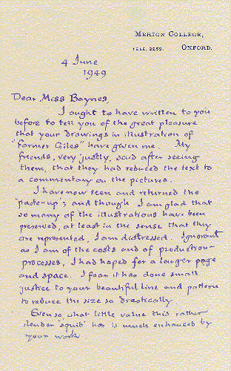
a fine letter to j.r.r. tolkien's favourite illustrator. Tolkien spent some time searching for a suitable illustrator for Farmer Giles of Ham. He turned down his publisher's first choice, however upon being shown some drawings in the Anglo-Saxon style, pronounced that this was the type of illustration he felt was suitable for his story. The artist was Pauline Diana Baynes and she was invited, in October 1948, to submit illustrations for the story. Her style of illustration continued to appeal to him greatly and in 1961 he wrote to her ''you seem able to produce wonderful pictures with a touch of ''fantasy'', but primarily bright and clean visions of things that one might really see''.

Hammond and Anderson report that Tolkien wrote to Ronald Eames on 10 December 1948 stating the first examples of her work were ''the perfect counterpart to the text (or an improvement on it) and to accord exactly in mood''. In March 1949 Tolkien wrote again to Eames and cites the reaction of his friends. The anecdote is also recalled for Baynes in this letter.

Despite claiming that the sequel to The Hobbit was ''finished'', the first volume of The Lord of the Rings was not published until July 1954. Hammond and Anderson note, with reference to The Lord of the Rings that ''Tolkien tended to wrongly predict its date of completion and underestimate its final size''. The volumes, when published, were not illustrated. In 1964, however, a 'deluxe' set was issued with a pictorial slipcase. The design for the slipcase comprised a 'triptych' view of Middle-Earth by Pauline Baynes. This depiction so impressed Tolkien that he asked for the watercolour and it remained in his possession until his death.

£3,000-5,000
EURO 4,850-8,100
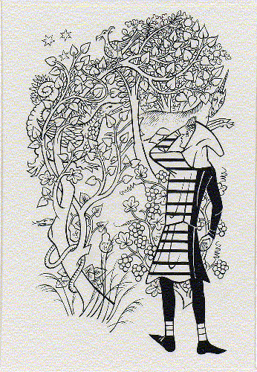

553 [Tolkien, J.R.R.]--Baynes, Pauline. Smith confronting a unicorn and a mythical creature in a deep and tangled forest full of snakes and birds, ink drawing for J.R.R. Tolkien's ''Smith of Wootton Major'', framed and glazed, 133 by 80mm.

it is rare for a drawing by tolkien's preferred illustrator to come on the market. Smith of Wootton Major was the third book illustrated by Pauline Baynes for J.R.R. Tolkien, being published in 1967. They had previously collaborated on Farmer Giles of Ham, 1949 and The Adventures of Tom Bombadil, 1962.

£1,000-1,500
EURO 1,600-2,450

554 Tolkien, J.R.R. Two autograph letters signed, one typed letter signed and one typed letter signed with initials to Pauline Gasch [née Baynes] regarding the illustration of The Adventures of Tom Bombadil (1962)

In the first letter Tolkien notes the genesis of the volume:

The notion really originated with an old lady, who for some reason is specially fond of Tom Bombadil, as he appears in ''The Lord of the Rings''. She thought that more about him, with pictures, would make a nice little book. So I naturally thought at once of you; and dug out the original verses about Tom that appeared long ago in a magazine.

Hoping that the verses ''...will at least amuse...'', Tolkien confesses doubt as to the cohesion of the collection (''...few of them really consort with Tom Bombadil, who is ra[t]her an odd creature'') and hopes that the illustrator will be moved ''to make some of your wonderful pictures''.
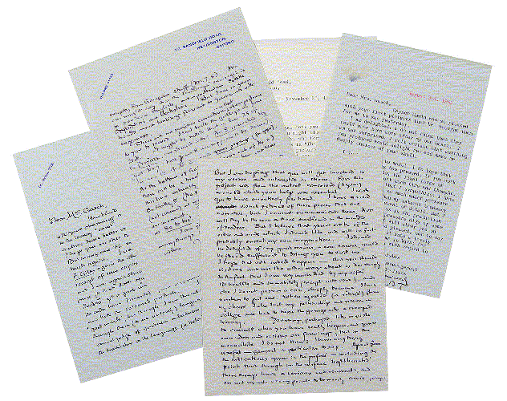
In the second letter Tolkien hopes that Baynes is ''still thinking kindly of cooperating'' and discusses a Swedish translation of Farmer Giles of Ham which he recently received (being ''...again struck by the enormous importance (to that little squib) of your work.'') Recalling his love of trees the author states he has ''...not cut down my three beautiful birches (grown from seedlings) yet; and I should arrest myself at once, if I detected any movement on my part in that direction'' and concludes with comments on the weather.

In the third letter, Tolkien notes his admiration of Baynes' working practices and laments his own (''...I very much admire and approve your wisdom and strength of mind in finishing one thing before becoming involved in another. I wish I could do this, or my circumstances would allow me to!'') He again asks for Baynes to work on the book (''...this project was from the outset conceived (by me) as one to which your help was essential...'') and hopes for a visit. Tolkien comments on the text and notes ''though on the surface 'lighthearted' these things have a serious undercurrent, and are not meant at any point to be merely comic, perhaps excepting Sam Gamgee's stuff''. He concludes with a list of corrections to the text.

The final letter, signed 'J.R.R.T.', records Tolkien's reaction to the first batch of pictures produced for the book:

I am delighted. I do not think that they could have been more after my own heart. I am not surprised: I felt certain that anything you produced would delight me -- and make me deeply envious of your skill.

He concludes by hoping that the illustrator is ''...not feeling too pressed'' and, again, provides a statement on his own working practices

If you work in any way like I do, the final forms of these things must cost much time and thought. All I can say is that I sympathize: I have been obliged to work so much under pressure (and distraction), when my natural tendency is to unlimited refinement of detail. But I have sometimes found... that pressure digs up some inspiration...

7 pages, 4to and 8vo, 76 Sandfield Road, Oxford, 23 November 1961 to 3 August 1962, minor tears to extremities of first letter, two ink spots to fourth letter

Tolkien's ''old lady'' who asked for the story of Tom Bombadil to be extended was his aunt, Jane Neave. The original poem appeared in the Oxford Magazine in 1934. In approaching his publishers, Tolkien noted that the book might ''do well'' if accompanied by illustrations by Pauline Baynes. By December 1961 Pauline Baynes had agreed to work on the volume and The Adventures of Tom Bombadil was published in November 1962.

£10,000-15,000
EURO 16,200-24,300

555 Tolkien, J.R.R. The Hobbit. George Allen and Unwin, 1937

8vo, first edition, first issue ('Dodgeson' corrected in ink on inside lower flap of dust-jacket), 10 illustrations and pictorial endpapers in red and black by the author, 2 pages of publisher's advertisements, original pictorial green cloth, original pictorial dust-jacket by the author, some light browning to end-papers, head and foot of spine frayed, spine slightly skewed, binding slightly soiled, soiled and browned dust-jacket with chips and tears to extremities (includes loss of 12 by 40mm. to head of spine, 5 by 30mm. to foot of spine and 8 by 45mm. to upper right corner of upper cover) with joint to upper flap split

References: Hammond and Anderson A3a

£4,000-6,000
EURO 6,500-9,700

556 Tolkien, J.R.R. The Hobbit. George Allen and Unwin, 1937

8vo, first edition, first issue ('Dodgeson' corrected in ink on inside lower flap of dust-jacket), 10 illustrations and pictorial endpapers in red and black by the author, 2 pages of publisher's advertisements, original pictorial green cloth, original pictorial dust-jacket by the author, ownership signature to A1, head and foot of spine slightly bumped, spine slightly skewed, minimal soiling at edges, slightly soiled and browned dust-jacket with chips and tears to extremities (includes loss of 25 by 50mm. to head of spine and 10 by 55mm. to lower left corner of lower cover)

References: Hammond and Anderson A3a

£5,000-7,000
EURO 8,100-11,300

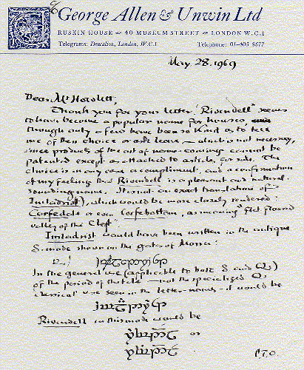
557 Tolkien, J.R.R. Fine autograph letter signed, discussing the name ''Rivendell''

to Anthony D. Howlett responding to his application to use the name of Elrond's house for the name of his own home. Tolkien mentions the recent use of this word as a house-name:

...only a few have been so kind as to tell me of their choice or ask leave - which is not necessary, since products of the art of name-coining cannot be patented... The choice is in any case a compliment, and a confirmation of my feeling that Rivendell is a pleasant and natural-sounding name.

Noting that the name ''...is not an exact translation of Imladrist...'', Tolkien suggests a closer rendering of the original ''...as meaning ''flat-floared valley of the Cleft''...'' and then provides versions in his elvish languages of Quenya and Sindarin with notes. Also included is an additional slip on which Tolkien summarizes his four versions of either ''Imladrist'' or ''Rivendell''.

2 pages, and additional slip, 8vo, c/o George Allen and Unwin [Bournemouth], 28 May 1969, typed envelope, creasing and soiling to envelope

£3,000-5,000
EURO 4,850-8,100
Photographs: © Sotheby’s, 2001

